Vehicle Safety Recalls
Join the U.S. Department of Transportation’s National Highway Traffic Safety Administration’s (NHTSA) safety initiative to educate the public about the importance of checking vehicles for open safety recalls.
- What is a vehicle recall, and why does it happen?
  - A recall is issued when a manufacturer or NHTSA determines that a vehicle, equipment, car seat or tire poses an unreasonable safety risk or fails to meet minimum safety standards.
  - Common issues include defective air bags, brakes, steering systems or electrical components.
  - Manufacturers are legally required to fix these problems free of charge.
- How are recalls identified?
  - NHTSA receives consumer complaints regarding vehicles and vehicle equipment. If the agency receives similar reports from several people about the same vehicle or product, this could indicate that a safety-related defect may exist that would warrant the opening of an investigation.
  - After screening and analyzing the frequent complaints, NHTSA opens an investigation of alleged safety defects. It is closed when they notify the manufacturer of recall recommendations, or they don’t identify a safety-related defect during the investigation.
  - NHTSA then monitors the effectiveness and management of recalls, including manufacturers’ filing of recall notices with NHTSA, communicating with owners regarding the recalls and tracking the completion rate of each recall.
- Does it cost money to fix a recall?
  - No. Recall repairs are always free at authorized dealerships. This includes parts and labor.
- Can I still drive my car before the recall repair?
  - It depends on the severity of the defect. Some recalls involve critical safety issues (e.g., air bags, brakes) that can cause serious injury or fatality.
  - If your recall notice says, “Do not drive,” follow that instruction immediately.
- How often should I check for recalls?
  - You should check for recalls at least twice a year, making it part of your regular vehicle maintenance. Recalls can affect vehicles of any age, including new models.
- Where can I search for open vehicle safety recalls?
  - NHTSA provides a free, user-friendly recall look-up tool that allows you to check for open safety recalls on your vehicles, motorcycles or automotive equipment.
- What happens if I ignore a recall?
  - Driving with an unrepaired recall can lead to severe injuries or fatalities.
  - In 2025 alone, there were 982 safety recalls affecting over 30 million vehicles, yet millions remain unrepaired.
- What do I need to check if my vehicle has a recall?
  - Either your vehicle identification number, often referred to as a VIN, or your license plate number.
- Why didn’t I receive a recall notice?
  - You may not be receiving your vehicle’s recall notices if you have a used vehicle. Take the initiative and sign up for safety recall alerts to make sure you’re informed about recalls that affect your safety.
- Where’s my VIN?
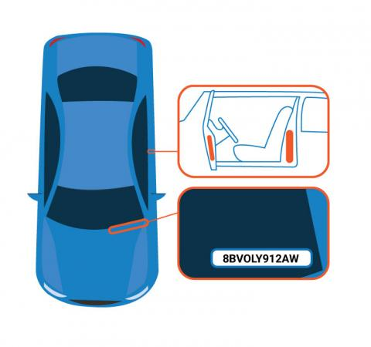
  - Every vehicle has a unique VIN. Look on the lower left of your car’s windshield for your 17-character VIN. Your VIN is also located on your vehicle’s registration card, and it may be shown on your insurance card.

Navigating NHTSA.gov/recalls
- What information will display in the search results?
  - When searching by license plate or VIN, you’ll learn if a specific vehicle needs to be repaired as part of a recall.
  - When searching by a vehicle’s year, make and model, or for car seats, tires or equipment, you'll get general results for recalls, investigations, complaints and manufacturer communications.
- What will the license plate and VIN search show?
  - An unrepaired recall for a vehicle from certain manufacturers.
  - If the vehicle has no unrepaired recalls, you will see the message: "0 unrepaired recalls associated with this VIN."
- What won’t the license plate and VIN search show?
  - A safety recall that has already been repaired.
  - Some recently announced safety recalls may not have affected all the VINs identified right away. VINs are added continuously, so please check regularly.
  - Safety recalls that are more than 15 years old (except where a manufacturer offers more coverage).
  - Safety recalls from small vehicle manufacturers, including some ultra-luxury brands and specialty applications.
  - Manufacturer customer service or other non-safety recall campaigns.
  - A recall involving an international vehicle.
- Why is the license plate search result showing a different vehicle?
  - License plate information is generated from state department of motor vehicles (DMVs). If the search result shows a vehicle you previously owned, rather than your new vehicle with the same license plate, contact your state DMV to request that your vehicle information be updated. In the meantime, you can search for recalls using your vehicle’s VIN.
- Other search options, including by NHTSA ID
  - You can also search for recalls and safety issues information by NHTSA ID and complaints by keyword.

Traffic Safety Marketing

